Average Calculator

Input:

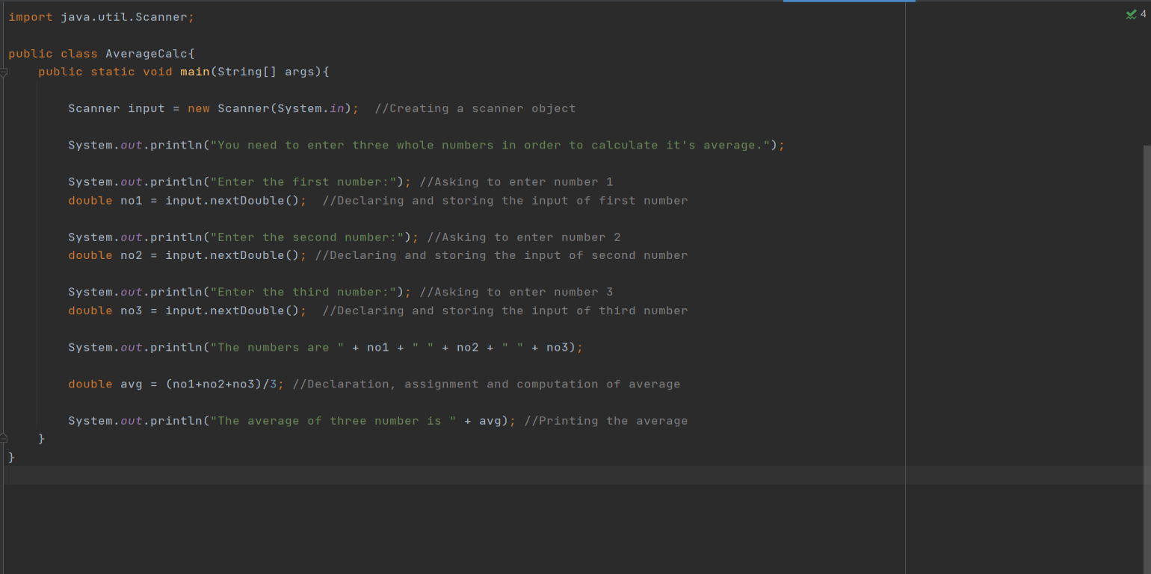

Output:

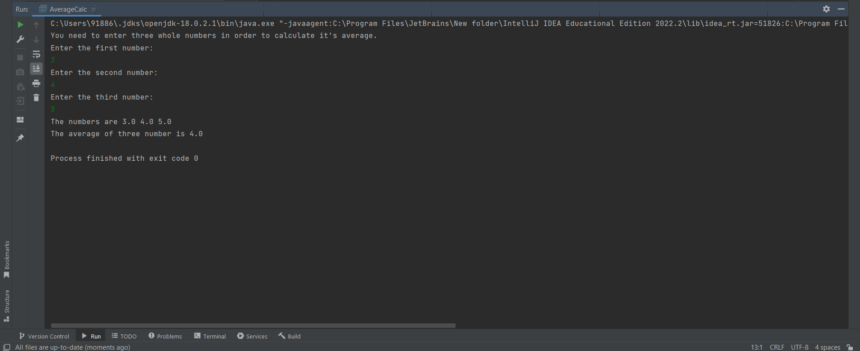

The average calculator code was pretty interesting as due to it my scanner skills got enhanced. It also gave me different approach to think about scanner. I did not face much challenges with this program, and had fun making a calculator.

Knock Knock Joke

Input:

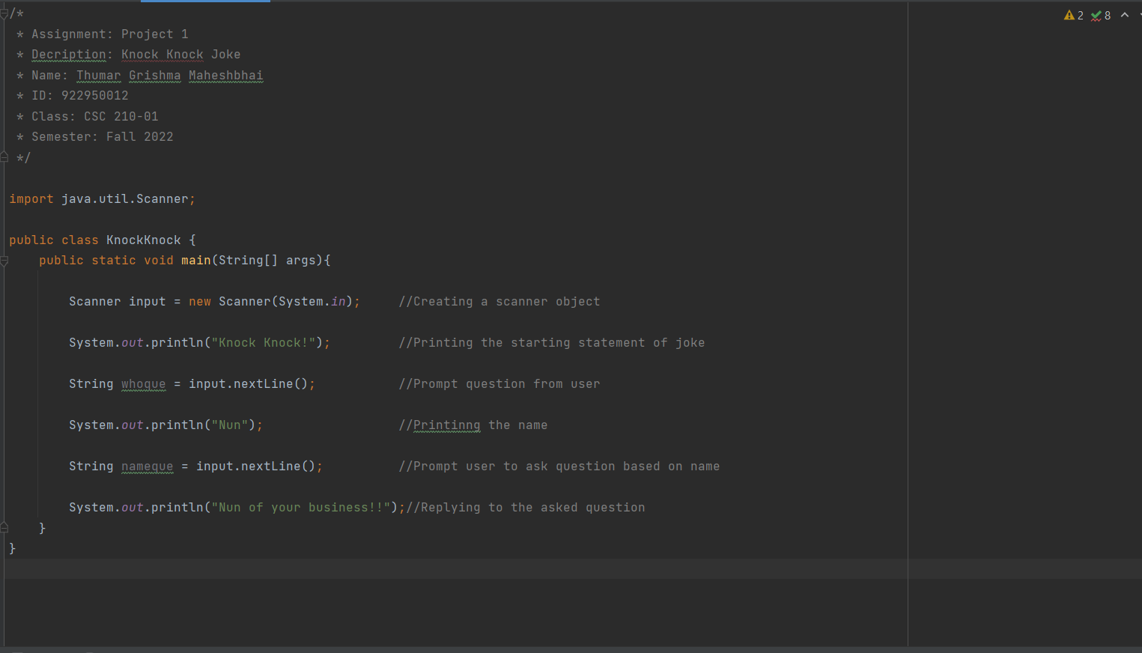

Output:

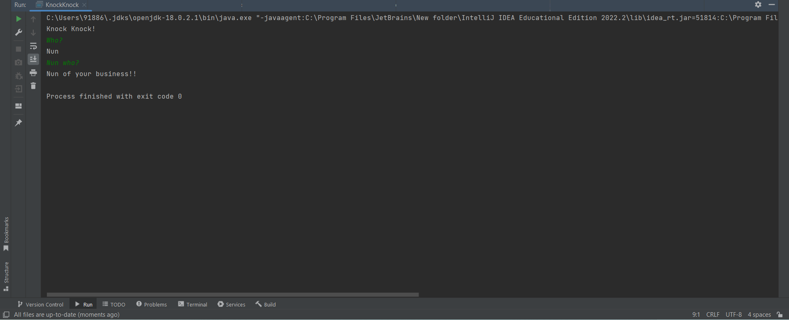

The knock knock joke was completely different experience because it was the first time, I was about to use scanner with the string. The challenge faced by me with it was how to use string in the scanner. In order to resolve it, I went through the textbook and also gone through various sites, and after trying various methods finally found one. At the end I was pleased by me, as I was able to do it without any assistance which gave me a confidence to solve those types of problems.

My Own Idea

Input:

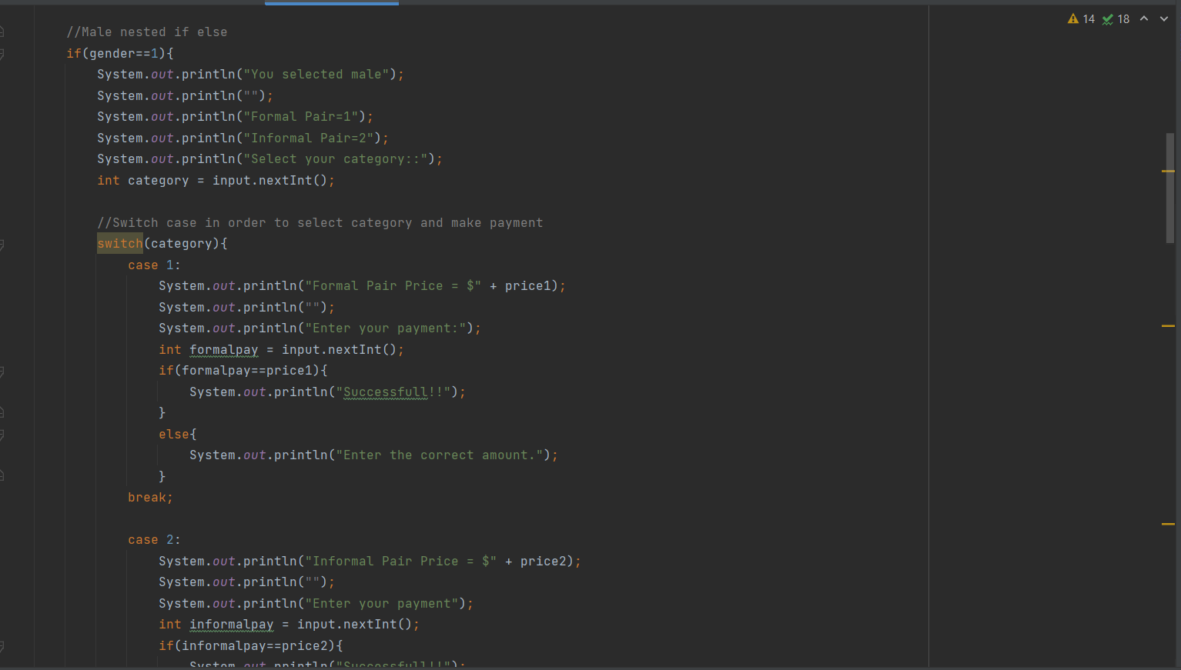

Output:

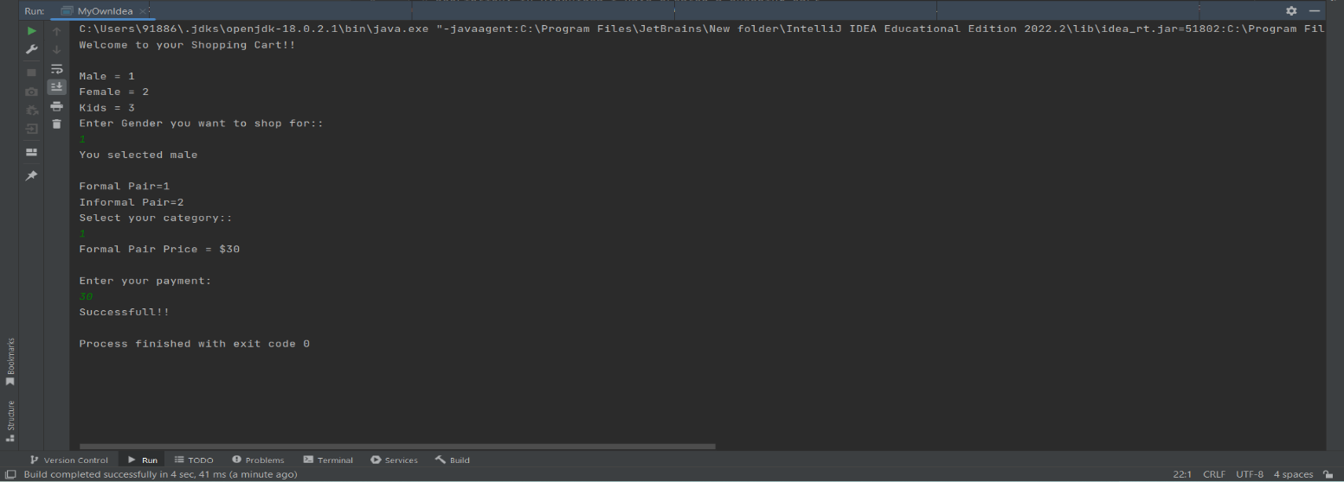

With My Own Idea, I created a Shopping Cart using print statement, scanner, if-else, and switch statements. It is a program where in the user first needs to enter the gender which they want to shop for which is coded using the if-else statement, thereby it displays the selected gender and the categories available such as formal or informal clothes. Afterwards, one needs to select the category, and then it displays the price, then one needs to enter the correct amount for payment which is done with the help of switch statement and if-else statement. If the amount is correct then only it shows successful, otherwise it tells to enter the correct amount. Finally, the code is completed. All the logic behind it is based on how to use scanner in order to enter and display the values as well as how to use the if-else statement and switch case in a proper way that is in a correct sequence. Another challenging thing was that at first, I only did the code with if-else statements, but then I decided to change some of it with switch case so I needed to make few updates in the code, especially with the curly braces which was at time confusing. It was too engaging for me as I got a chance to explore it.